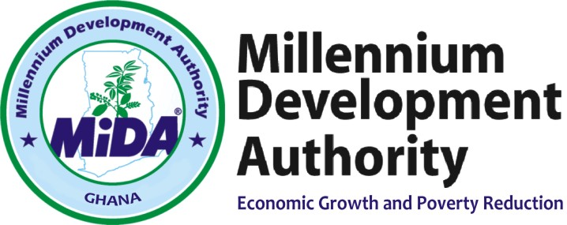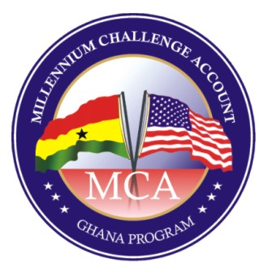

Millennium Development Authority (MiDA)

-------------------------------------------------------
ADDENDUM FOR THE EXTENSION OF DEADLINE FOR SUBMISSION OF PROPOSALS
-------------------------------------------------------

RE: CONSULTANCY SERVICES TO DEVELOP ENERGY EFFICIENCY STANDARDS AND LABELLING LEGISLATIVE INSTRUMENTS

RFP REF: 5610500/RFP/QCBS/11/18

In accordance with Section I, ITC Clause 9 of the Request for Proposal, MiDA has taken a decision to extend the Proposal Submission Date from the 18th January 2019 to the 1st February 2019.

The deadline for submission remains the same as 15:00 hours (Local time in Ghana).

MiDA Procurement Agent
for the
Chief Executive Officer
Millennium Development Authority
4th Floor Heritage Tower, 6th Avenue.
Ridge West, Accra, Ghana.

